# Normalization and Standardization

<https://www.youtube.com/watch?v=bqhQ2LWBheQ&t=84s>

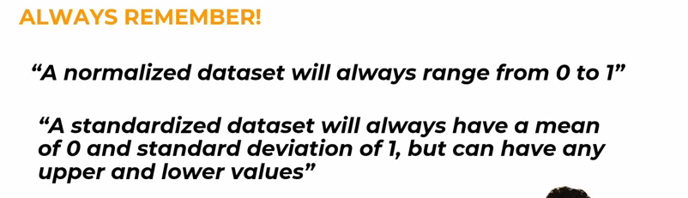

Standardization is also called Z-score Normalization.

